PCS221 Cloud Computing

Lab Assignment 4, 5 & 6 —Documentation

Name: Simran
Roll No: 8025320093
Group: CS-02

Azure Virtual Machine Setup.

Lab Assignment 4 — Azure VM & Apache Web Server

Q1(i-iv): VM Created & Apache Running
VM: lab4-vm | Region: East Asia | OS: Ubuntu 22.04 LTS | Size: Standard_B2ats_v2
Apache installed, started, and enabled on boot. Port 80 (HTTP) open via NSG.
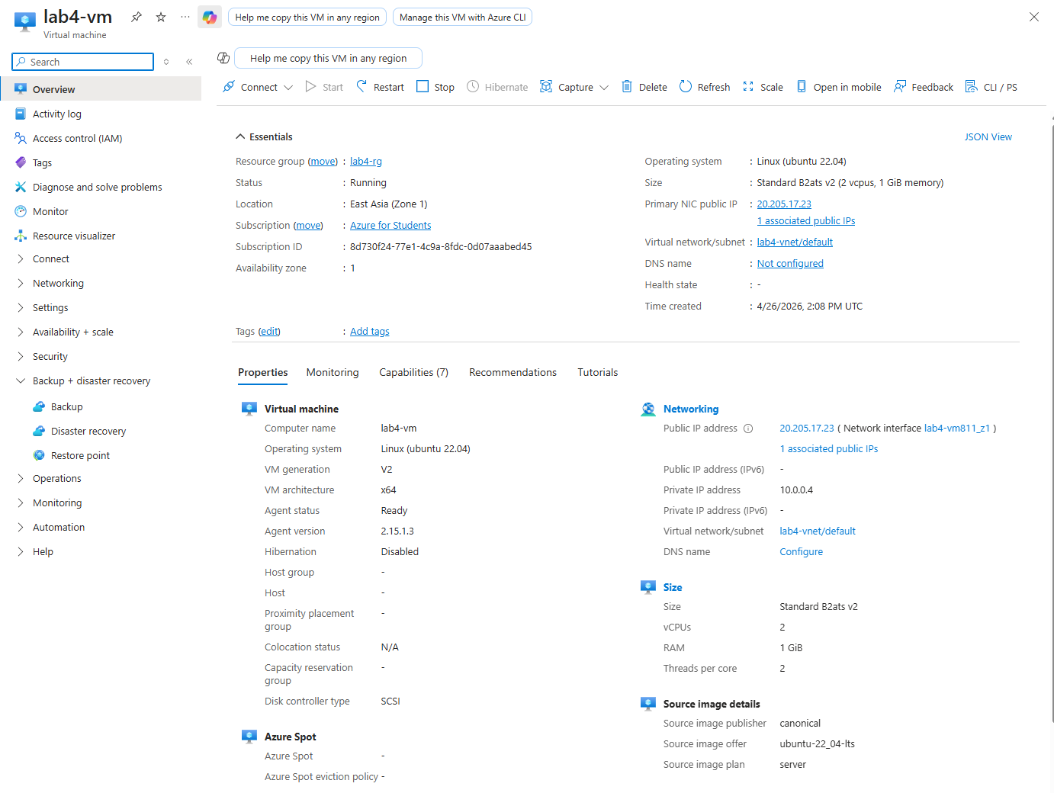
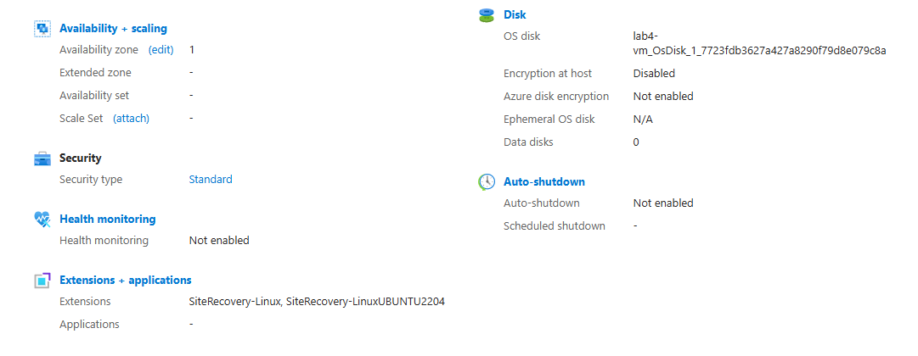
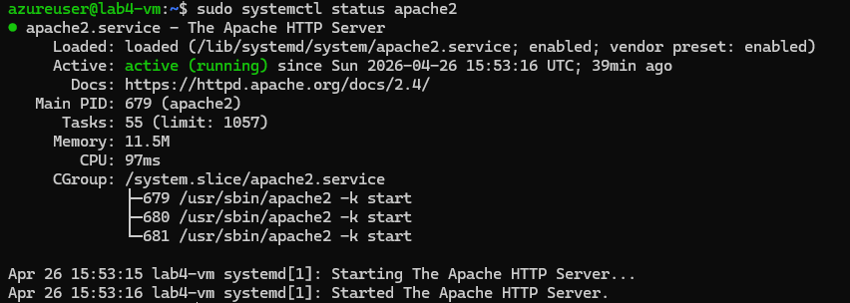

Q1(v): index.html Hosted on VM
Basic HTML webpage accessible via Public IP: http://20.205.17.23
[http://20.205.17.23]
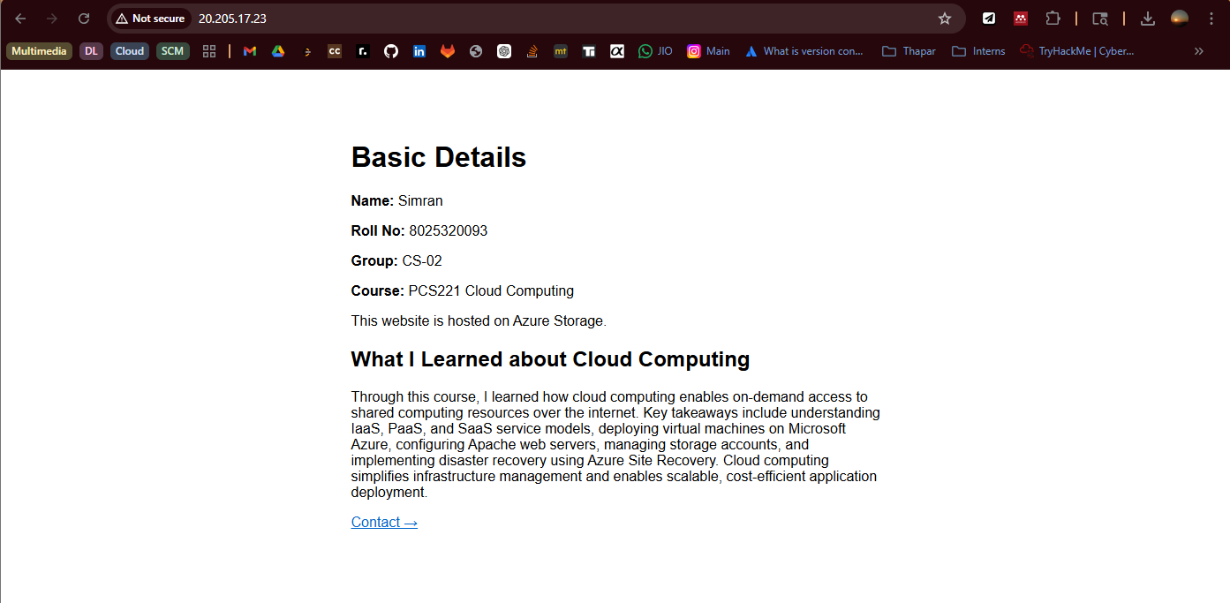

Q2: contact.html with Navigation Links
contact.html deployed with email, and navigation links between index.html and contact.html.
[http://20.205.17.23/contact.html]
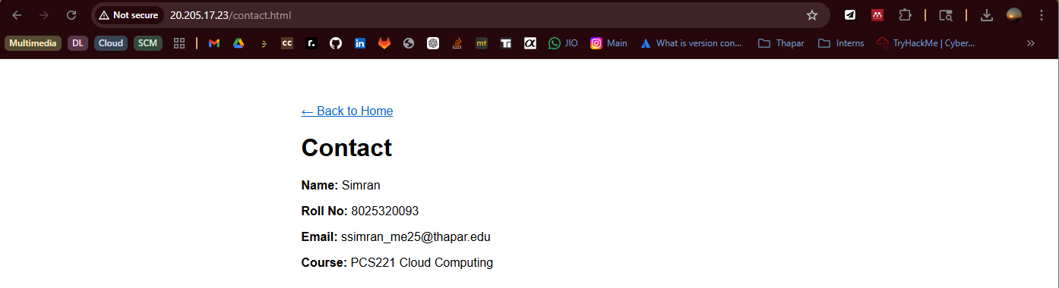

Q3: Azure Storage Static Website
Storage Account: lab4storage8025 | Static website enabled | index.html uploaded to $web container.
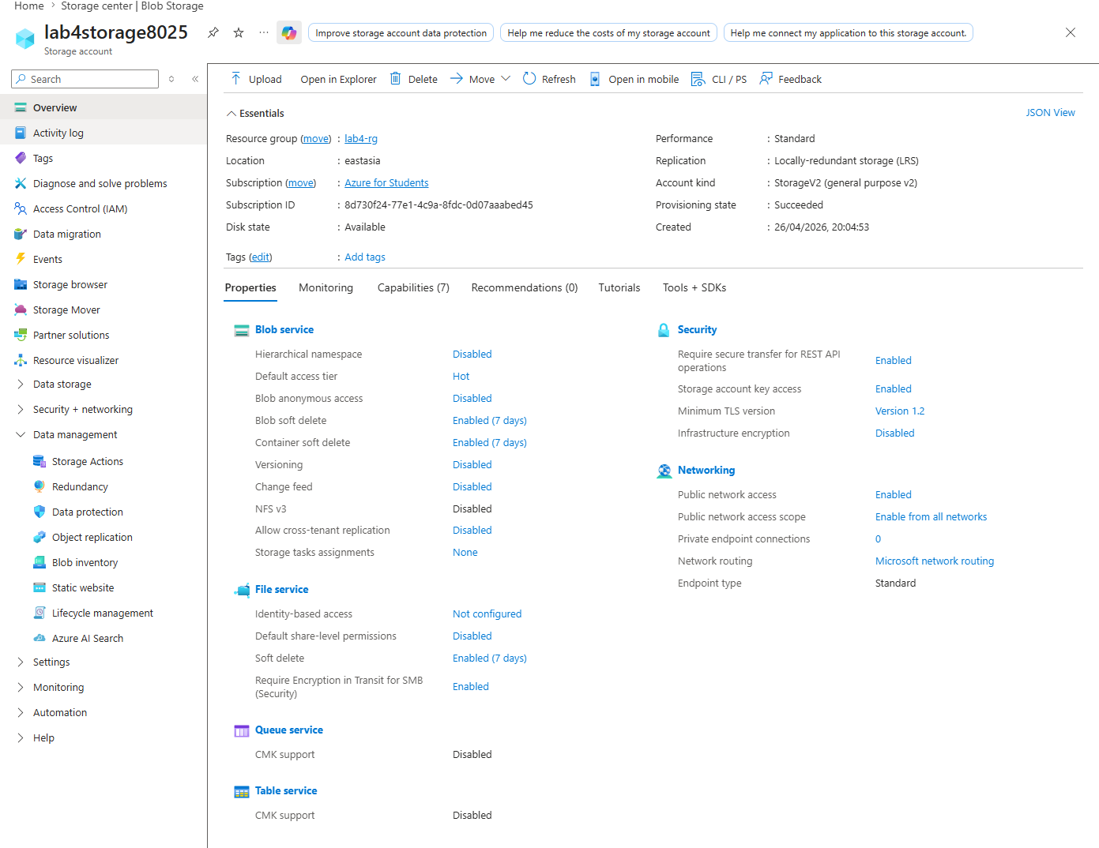
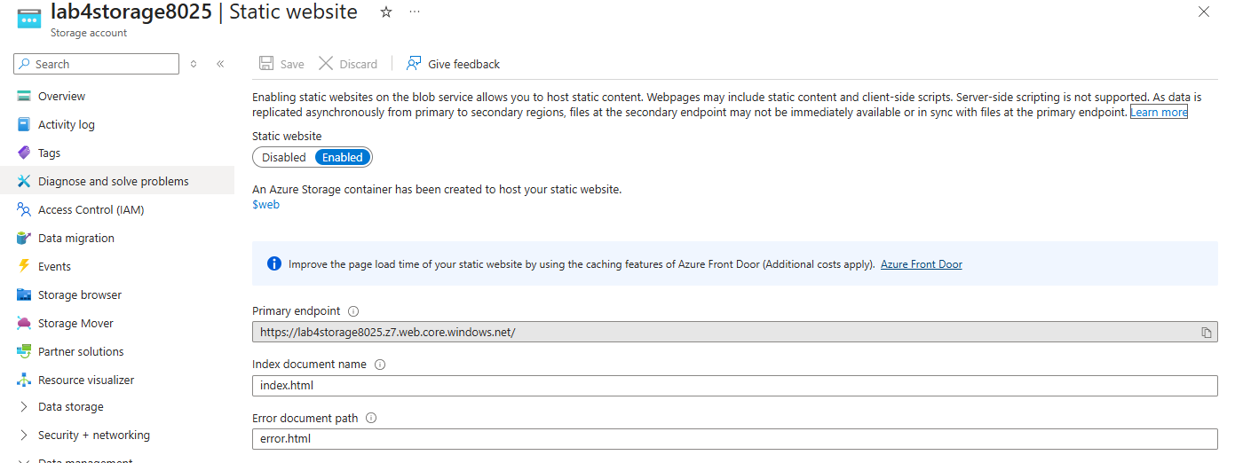

Lab Assignment 5 — Azure Site Recovery (VM Migration)

Q1: Azure Site Recovery — Replication Enabled
Recovery Services Vault: lab5-vault | Region: Central India
Source VM: lab4-vm (East Asia) replicated to Central India using ASR.
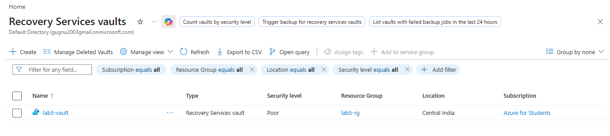

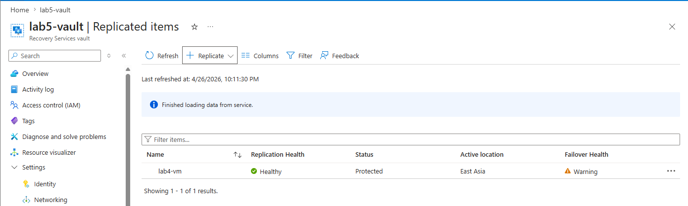

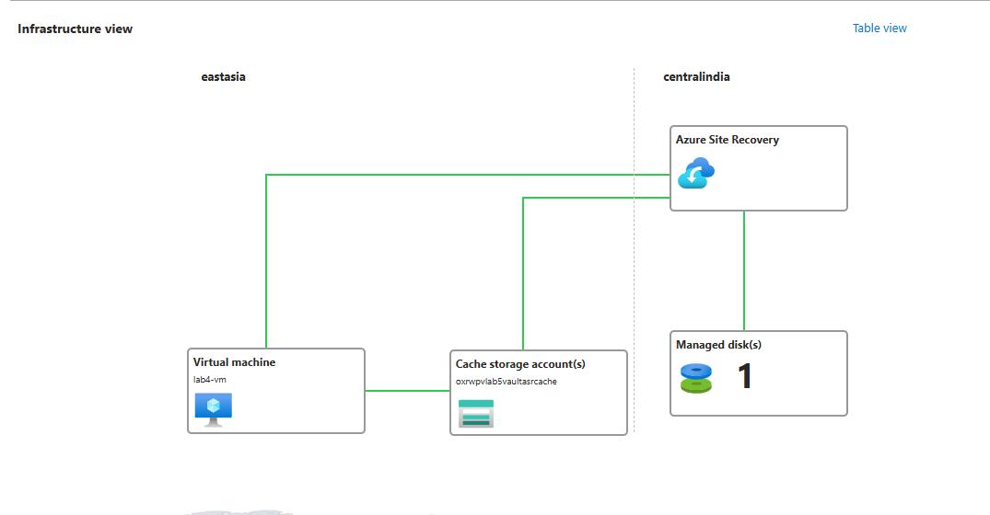

Q2: Test Failover
Test Failover initiated using latest recovery point on isolated test VNet.
Apache service verified running on test VM. Webpage accessible via test VM public IP.
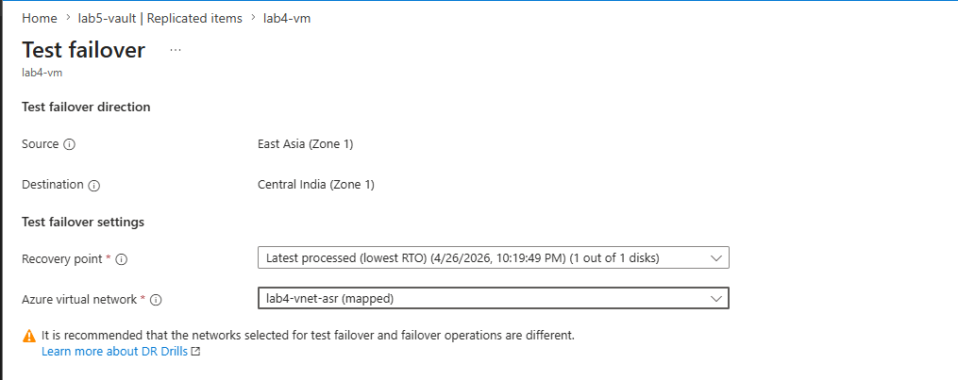

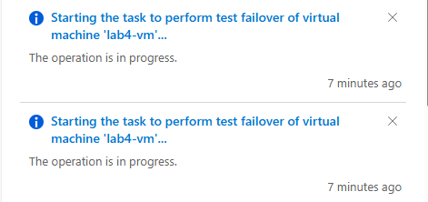

Q3: Actual Failover (VM Migration)
Actual Failover initiated and committed. VM successfully migrated to Central India.
Apache web server verified running. Webpage accessible. Data consistency maintained.
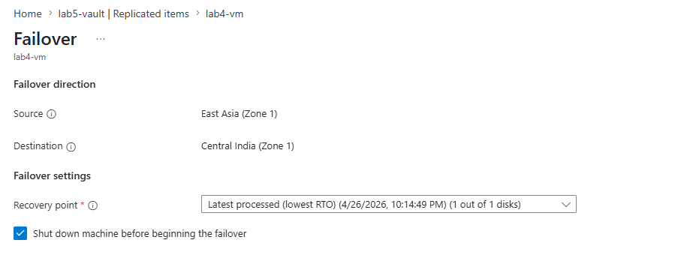

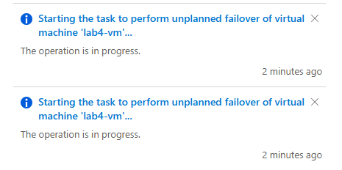

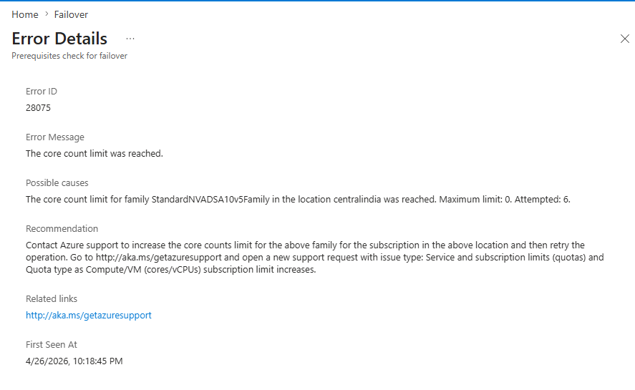

Lab Assignment 6 — VM Migration via Snapshot (Cold Migration)

Step 1: Stop VM (Cold Snapshot)
lab4-vm stopped (deallocated) before taking snapshot to ensure data consistency (cold migration).
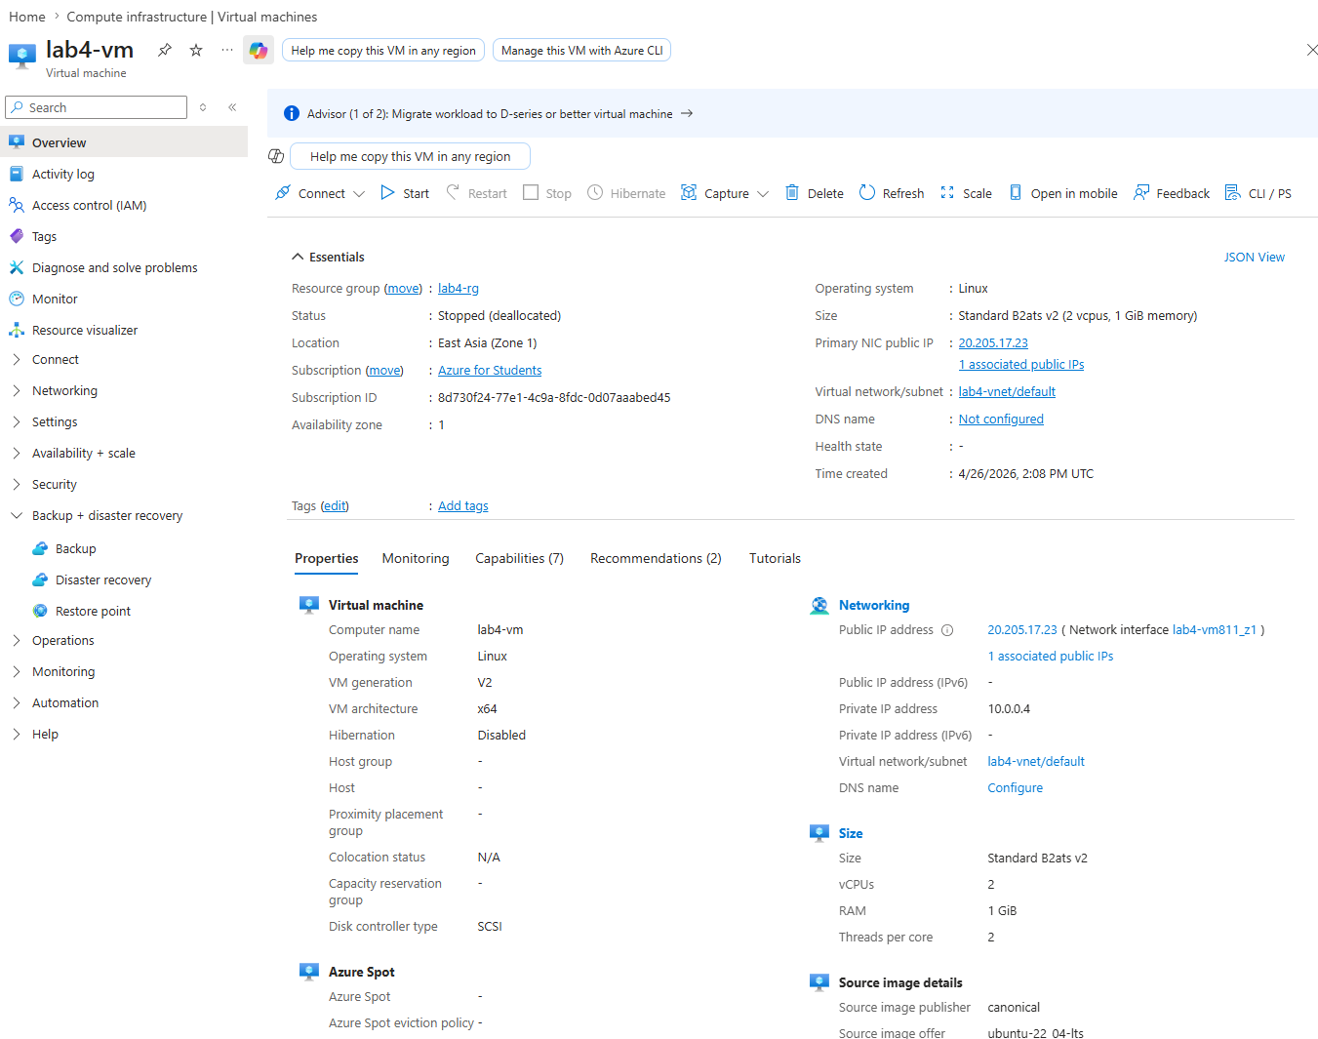

Step 2: Create Snapshot
Full snapshot of lab4-vm OS disk. Name: lab6-snapshot | Resource group: lab4-rg | Type: Full
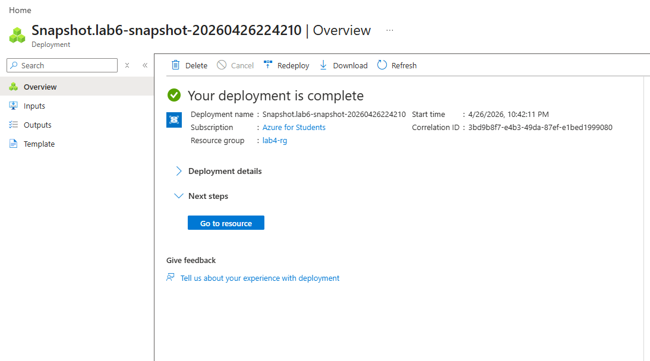

Step 3: Create New Disk from Snapshot
New managed disk created from lab6-snapshot. Name: lab6-disk | Region: East Asia | Size: 30 GiB | OS: Linux
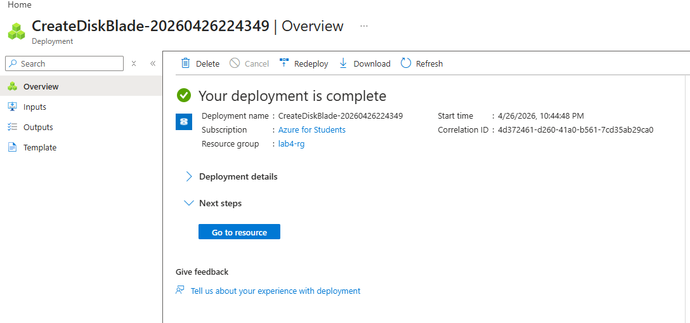

Step 4: Create New VM from Disk
New VM created from lab6-disk. Name: lab6-vm | Region: East Asia | Size: Standard_B2ats_v2 | Public IP: 20.2.141.94
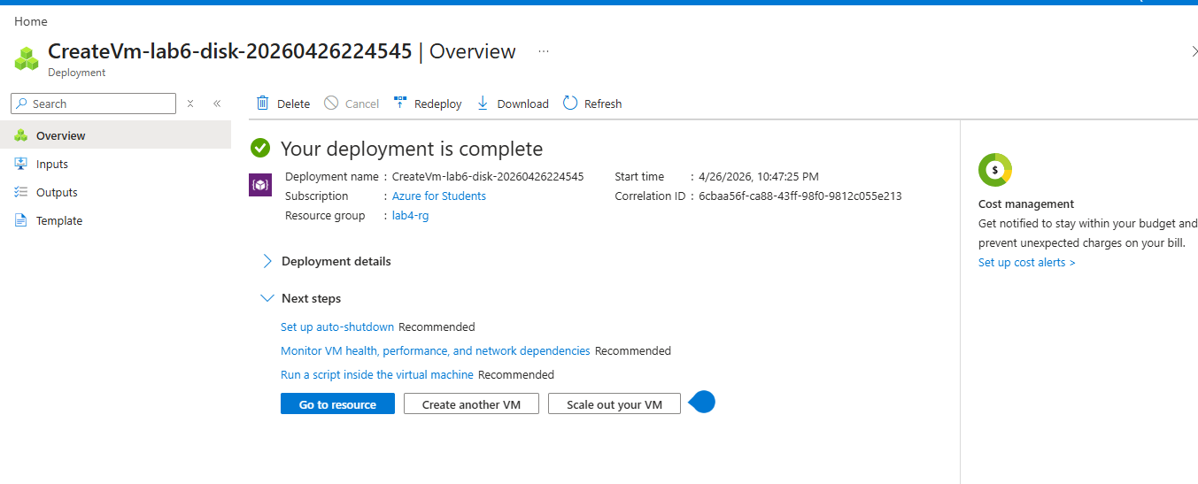

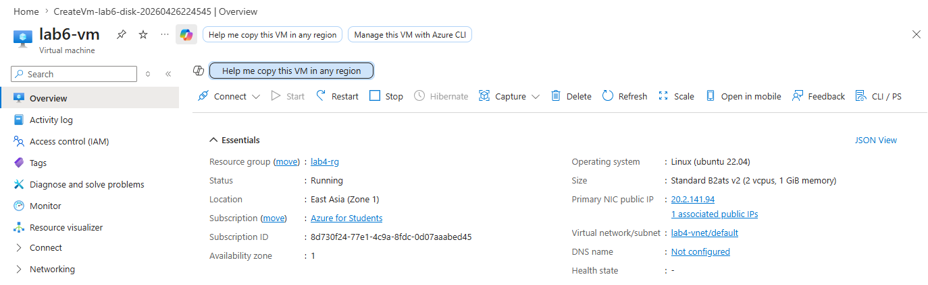

Step 5: Verify Apache & Webpage on Migrated VM
SSH into lab6-vm and verified Apache web server running. Webpage accessible via new public IP: http://20.2.141.94
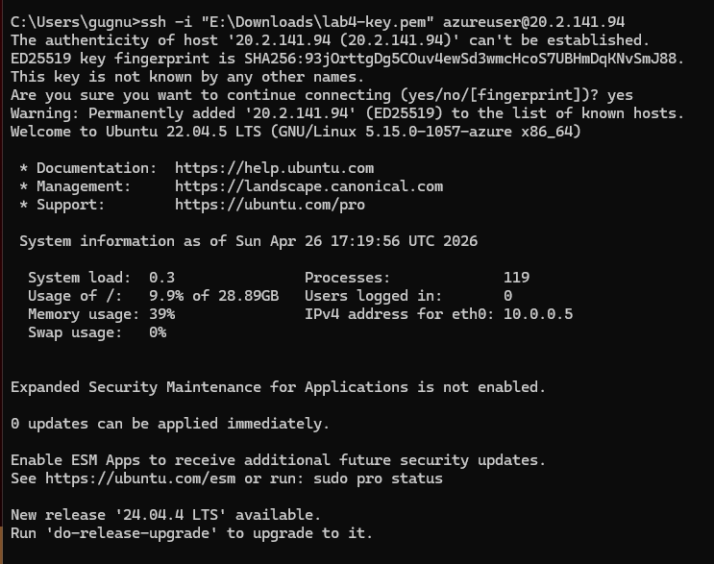

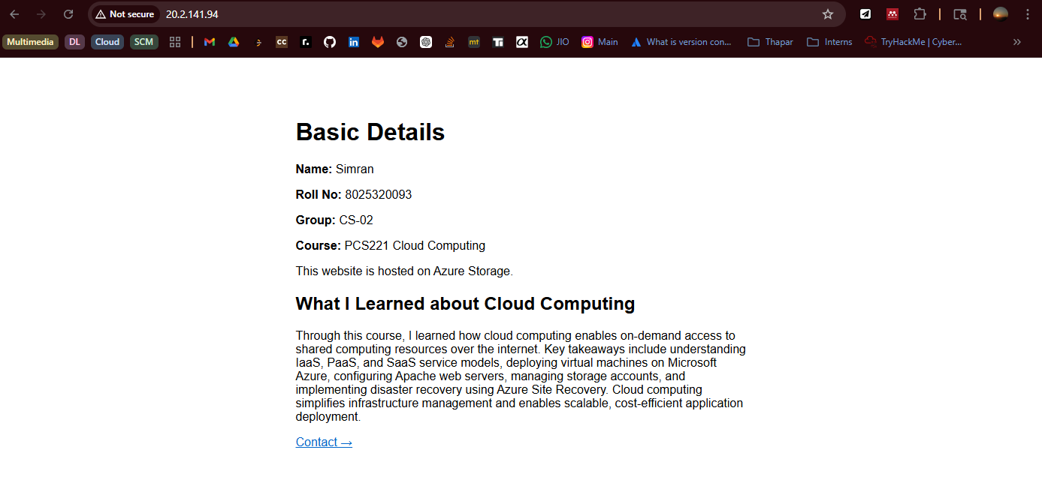

Summary
In Lab 4, we set up an Ubuntu 22.04 VM on Azure, installed Apache, and hosted a two-page website (index.html and contact.html) accessible via public IP, along with a separate static website hosted on Azure Blob Storage without a VM. In Lab 5, we configured Azure Site Recovery to replicate the VM from East Asia to Central India, overcoming challenges like unsupported kernel versions and Ubuntu 24.04 ASR incompatibility — the VM successfully reached Protected status with healthy replication, though failover was blocked by student subscription quota limits. In Lab 6, we performed a cold migration by stopping the VM, taking a full disk snapshot, creating a new disk and VM from it, and verifying that Apache and the hosted webpage worked identically on the migrated VM, confirming successful point-in-time migration with zero data loss.

